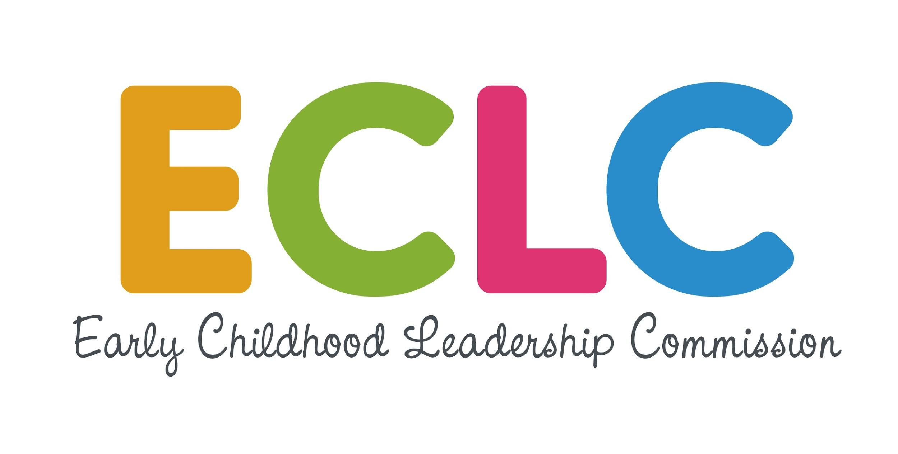 Colorado’s State Advisory Council for Early Childhood
ECPD Working Advisory Group
August 6, 2019 1:00pm-3:00pm
Colorado Department of Health Care Policy & Financing
1570 Grant St, Denver, CO 80203

1:00-1:10 Welcome and Introductions Pamela Harris
1:10-1:40 Early Childhood Professional Credential Work Work Group Reps.
Group Presentation
1:40-2:45 Early Childhood Workforce 2020 Plan Mapping Angela Ben-Zekry
Discussion and Exercise
2:45-2:50 Public Comment Pamela Harris
2:50-3:00 Wrap Up Rebecca Kantor

Meeting Evaluation Form
- Paper evaluation forms available at meeting
- See calendar marker for link https://forms.gle/9XX7XxyJq44DkixB6

Next Meetings

- Tuesday, October 1, 2019 @ HCPF 1pm-3pm
- Tuesday, December 3, 2019, 1-3pm

Submit Agenda Options for Upcoming Meetings
- See calendar marker for link https://docs.google.com/spreadsheets/d/1XNbLIrhNTSTeXpicDraqNEDGPI_MtnJ6TXawzoihEb4/edit?usp=sharing

